**NETWORKING & SYSTEM ADMINISTRATION LAB**

**Experiment No.:**

**Aim**

NETCAT INSTALLATION

**Procedure &Output Screenshot**

Sudo apt-get install netcat: Installing netcat.

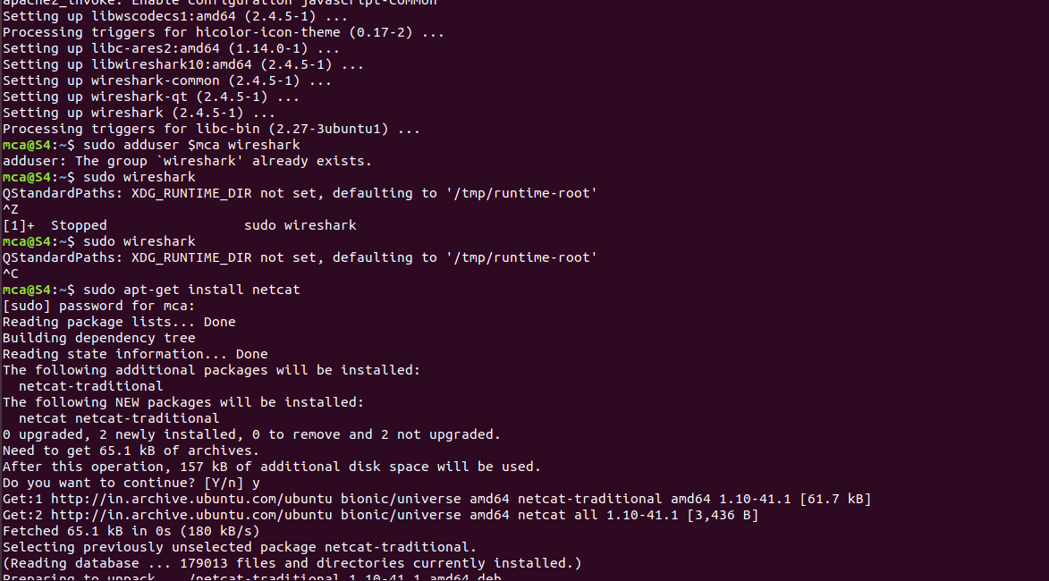

Nc –l –p 1234: To set up the server using Netcat in listening mode. We will use port 12345 and will specify the port number with the -p option.

C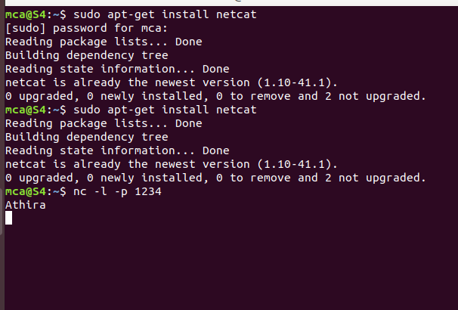

1. Nc 127.0.0.1 1234: The client needs the server ip to connect to it. My server and my client are on the same machine so I use localhost for the hostname. The command ‘nc hostname port’ puts Netcat in client mode and connects to the specified hostname on the specified port.

